QUESTION PAPER
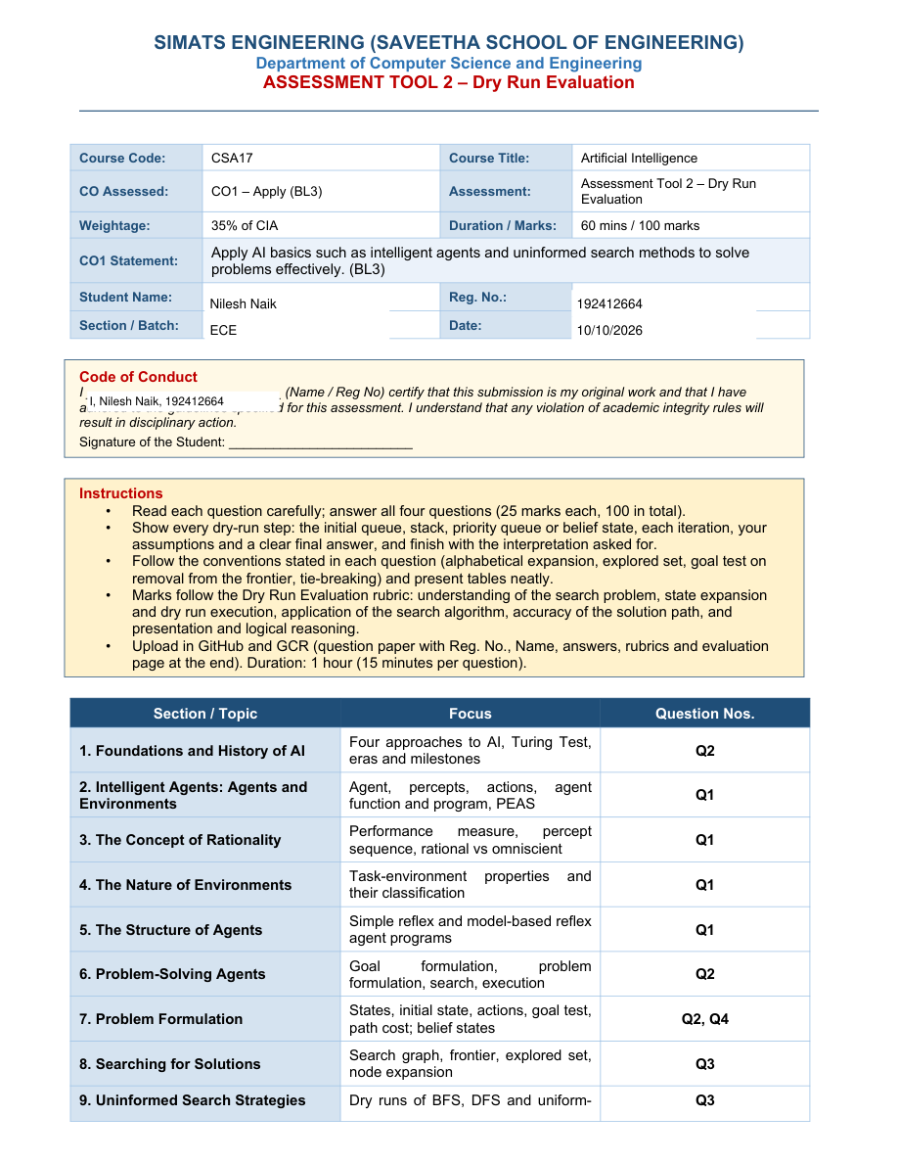



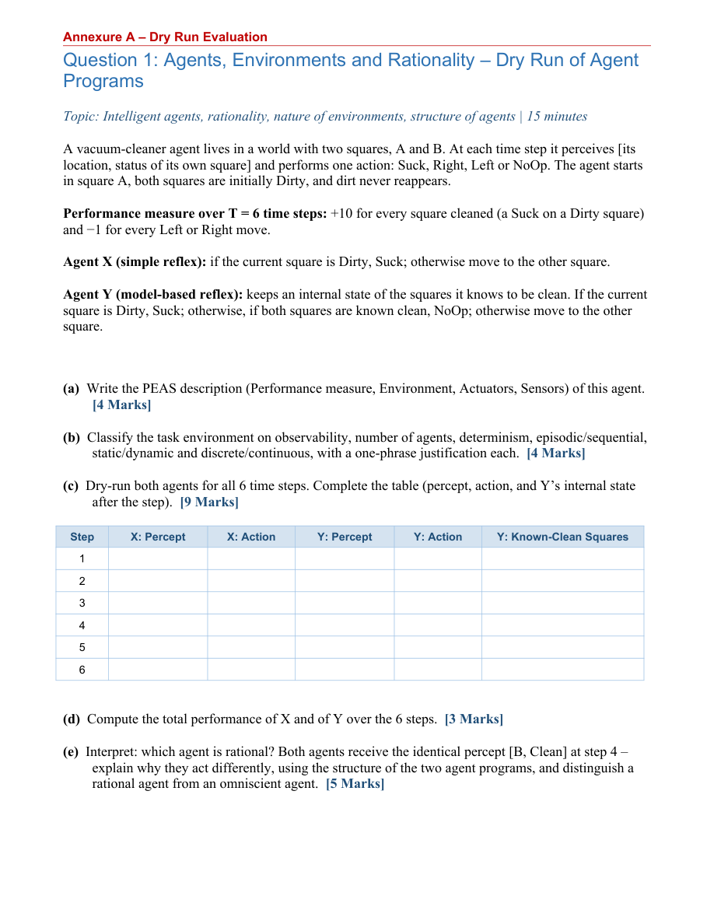

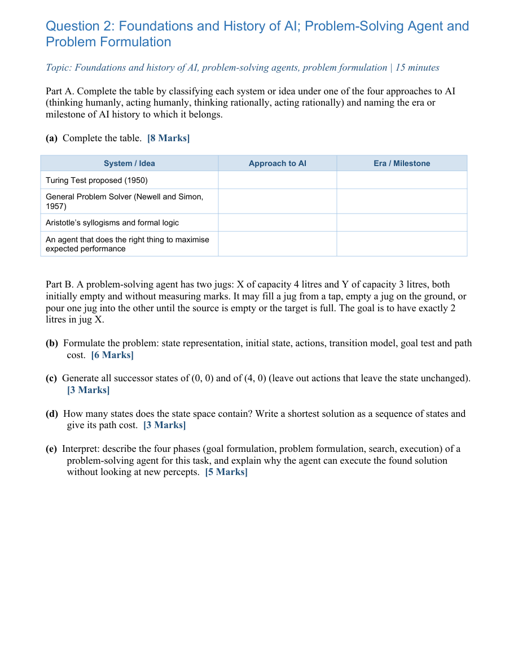

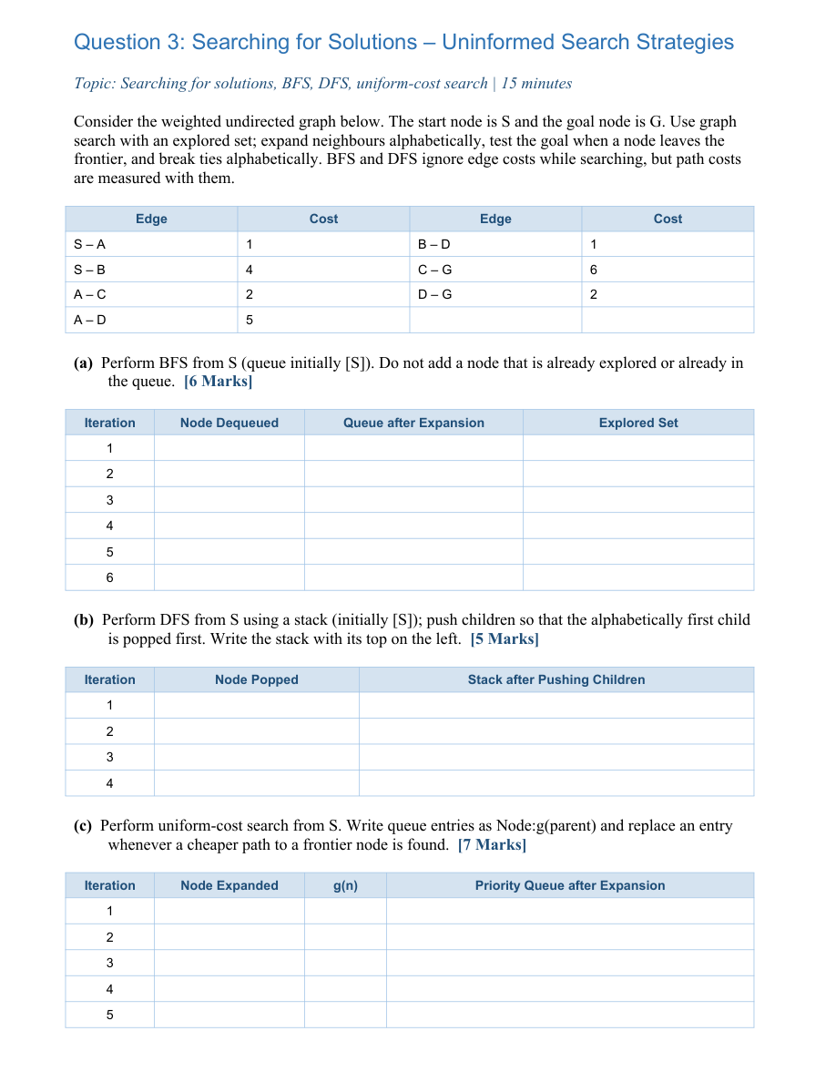

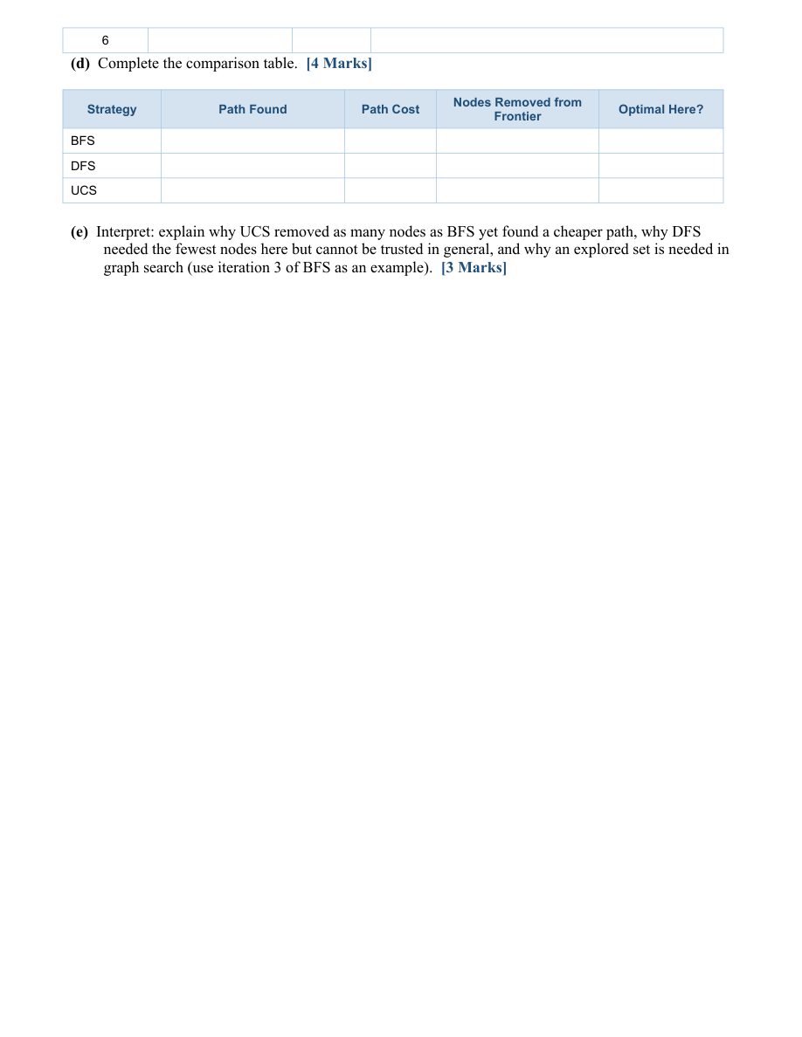

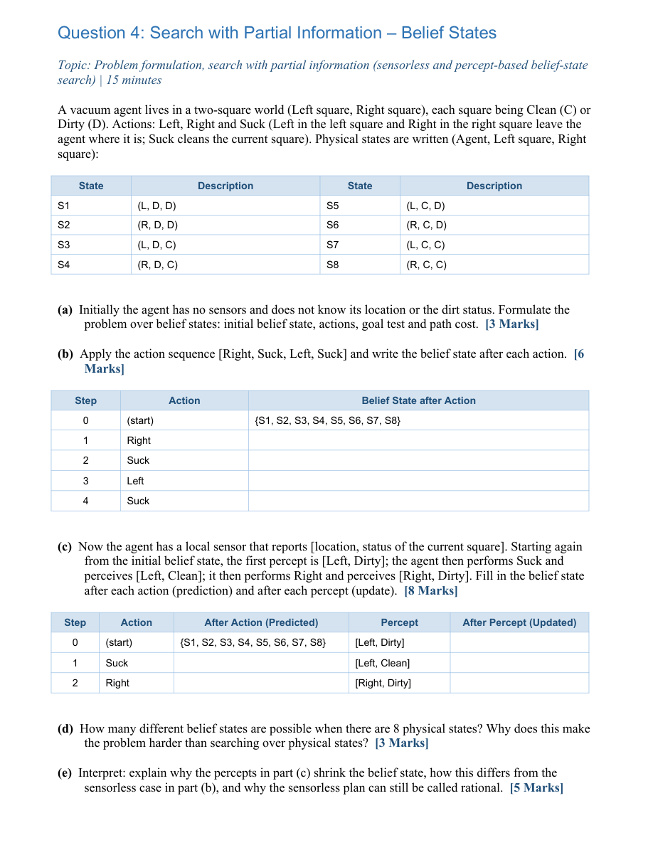

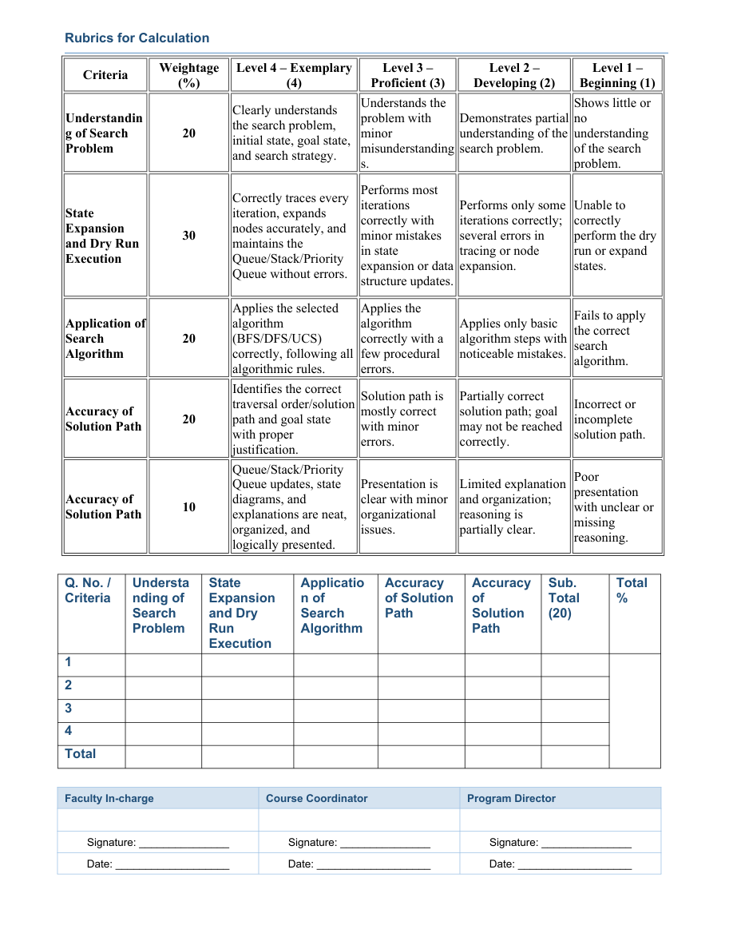

ANSWER SHEET
SIMATS ENGINEERING – SAVEETHA SCHOOL OF ENGINEERING
CSA17 – ARTIFICIAL INTELLIGENCE | ASSESSMENT TOOL 2 – DRY RUN EVALUATION
Student Name | Nilesh Naik | Reg. No. | 192412664
Section / Batch | ECE | Date | 10/10/2026
QUESTION 1: AGENTS, ENVIRONMENTS AND RATIONALITY
(a) PEAS description
Element | Description
Performance measure | +10 for every square cleaned; −1 for each Left/Right move over 6 time steps.
Environment | Two squares, A and B; both initially dirty; dirt never reappears.
Actuators | Suck, Right, Left, NoOp.
Sensors | Current location and status of the current square.
(b) Task-environment classification
Property | Classification | Justification
Observability | Partially observable | Only the current square status is perceived.
Agents | Single-agent | Only one vacuum agent acts.
Determinism | Deterministic | Actions have predictable effects.
Episodic/sequential | Sequential | Actions affect later states and choices.
Static/dynamic | Static | Dirt does not reappear and the world does not change independently.
Discrete/continuous | Discrete | States, actions and time steps are discrete.
(c) Six-step dry run
Step | X percept | X action | Y percept | Y action | Y known-clean after step
1 | [A, Dirty] | Suck | [A, Dirty] | Suck | {A}
2 | [A, Clean] | Right | [A, Clean] | Right | {A}
3 | [B, Dirty] | Suck | [B, Dirty] | Suck | {A, B}
4 | [B, Clean] | Left | [B, Clean] | NoOp | {A, B}
5 | [A, Clean] | Right | [B, Clean] | NoOp | {A, B}
6 | [B, Clean] | Left | [B, Clean] | NoOp | {A, B}
Assumption: after a Suck action on a dirty square, Agent Y records that square as clean. Agent Y stays at B after step 4 because both squares are known clean.
(d) Total performance
Agent X: +20 for cleaning two squares and −4 for four moves. Total = 16.
Agent Y: +20 for cleaning two squares and −1 for one move. Total = 19.
(e) Interpretation
Agent Y performs better over the six-step horizon (19 versus 16). At step 4, both agents perceive [B, Clean]. Agent X is a simple reflex agent and moves to the other square whenever its current square is clean. Agent Y is model-based and remembers that both squares are clean, so it selects NoOp. A rational agent chooses actions expected to maximize performance using its percept history and knowledge; an omniscient agent would know the actual state and outcomes completely.
QUESTION 2: FOUNDATIONS AND HISTORY OF AI; PROBLEM-SOLVING AGENT
(a) Four approaches to AI and milestones
System / idea | Approach to AI | Era / milestone
Turing Test (1950) | Acting humanly | Early AI foundations; test of human-like conversational behaviour.
General Problem Solver (1957) | Thinking humanly | 1950s symbolic AI and cognitive modelling.
Aristotle's syllogisms and formal logic | Thinking rationally | Ancient foundations of formal logic.
Agent maximizing expected performance | Acting rationally | Rational-agent approach in modern AI.
(b) Two-jug problem formulation
Element | Formulation
State | (x, y), where 0 ≤ x ≤ 4 and 0 ≤ y ≤ 3.
Initial state | (0, 0).
Actions | Fill, empty, or pour either jug into the other.
Transition model | Update amounts according to capacities; pouring stops when source is empty or target is full.
Goal test | x = 2 litres.
Path cost | Unit cost 1 per action.
(c) Successor states
From (0,0): (4,0) by Fill X; (0,3) by Fill Y.
From (4,0): (0,0) by Empty X; (4,3) by Fill Y; (1,3) by Pour X into Y.
(d) State space and shortest solution
State-space size = (4+1)(3+1) = 20 states.
Shortest solution: (0,0) → (0,3) → (3,0) → (3,3) → (4,2) → (0,2) → (2,0). Actions: Fill Y, pour Y→X, fill Y, pour Y→X, empty X, pour Y→X. Path cost = 6.
(e) Four phases
Goal formulation specifies 2 litres in X. Problem formulation defines states, actions, transitions, goal and cost. Search finds a sequence reaching x=2. Execution performs the sequence. Because the model is deterministic and the actions are assumed to work as specified, the plan can be executed without new percepts.
QUESTION 3: SEARCHING FOR SOLUTIONS – UNINFORMED SEARCH
Edges: S–A=1, S–B=4, A–C=2, A–D=5, B–D=1, C–G=6, D–G=2. Neighbours are considered alphabetically; the goal is tested when removed from the frontier.
(a) Breadth-first search (BFS)
Iteration | Node dequeued | Queue after expansion | Explored set
1 | S | [A, B] | {S}
2 | A | [B, C, D] | {S, A}
3 | B | [C, D] | {S, A, B}
4 | C | [D, G] | {S, A, B, C}
5 | D | [G] | {S, A, B, C, D}
6 | G (goal) | [] | {S, A, B, C, D, G}
BFS path: S → A → C → G. Cost = 1 + 2 + 6 = 9.
(b) Depth-first search (DFS)
Iteration | Node popped | Stack after pushing children (top left)
1 | S | [A, B]
2 | A | [C, D, B]
3 | C | [G, D, B]
4 | G (goal) | [D, B]
DFS path: S → A → C → G. Cost = 9.
(c) Uniform-cost search (UCS)
Iteration | Node expanded | g(n) | Priority queue after expansion
1 | S | 0 | [A:1(S), B:4(S)]
2 | A | 1 | [C:3(A), B:4(S), D:6(A)]
3 | C | 3 | [B:4(S), D:6(A), G:9(C)]
4 | B | 4 | [D:5(B), G:9(C)]
5 | D | 5 | [G:7(D)]
6 | G (goal) | 7 | []
UCS replaces D:6(A) with D:5(B), then replaces G:9(C) with G:7(D). UCS path: S → B → D → G; cost = 7.
(d) Comparison
Strategy | Path | Cost | Nodes removed | Optimal here?
BFS | S→A→C→G | 9 | 6 | No; minimizes edge count.
DFS | S→A→C→G | 9 | 4 | No; traversal-order dependent.
UCS | S→B→D→G | 7 | 6 | Yes; nonnegative costs.
(e) Interpretation
UCS and BFS each remove six nodes here, but UCS orders the frontier by cumulative cost and finds the cheaper path through B and D. DFS reaches G quickly under this ordering, but is not generally optimal. An explored set prevents cycles and duplicate expansions; at BFS iteration 3, D is already in the frontier when B is expanded, so it is not added again.
QUESTION 4: SEARCH WITH PARTIAL INFORMATION – BELIEF STATES
(a) Belief-state formulation
Initial belief state: {S1,S2,S3,S4,S5,S6,S7,S8}. Actions: Left, Right, Suck. Goal test: all states in the belief state have both squares clean (S7 or S8). Path cost: 1 per action.
(b) Sensorless sequence [Right, Suck, Left, Suck]
Step | Action | Belief state after action
0 | Start | {S1,S2,S3,S4,S5,S6,S7,S8}
1 | Right | {S2,S4,S6,S8}
2 | Suck | {S4,S8}
3 | Left | {S3,S7}
4 | Suck | {S7}
(c) Prediction and percept update
Step | Action | Predicted belief | Percept | Updated belief
0 | Start | — | [Left, Dirty] | {S1,S3}
1 | Suck | {S5,S7} | [Left, Clean] | {S5,S7}
2 | Right | {S6,S8} | [Right, Dirty] | {S6}
(d) Number of belief states
There are 2^8 = 256 possible subsets of the eight physical states, including the empty set. Belief-state search can therefore be exponentially larger than search over physical states.
(e) Interpretation
Percepts remove states inconsistent with observations: [Left, Dirty] leaves {S1,S3}; after Suck, [Left, Clean] leaves {S5,S7}; after Right, [Right, Dirty] leaves {S6}. Sensorless search has no percept updates and propagates all possible states. The sensorless plan is rational because it reaches {S7}, where both squares are clean, for the given initial belief state.
END OF ANSWER SHEET
Student signature: __________________________________________

